Basic Bringup: Cryorefrigerator

# Introduction

This document is an ongoing document detailing the current status of the quick test cryorefrigerator. The intent of this document is to note current problems and attempted solutions as well as providing a history for the project.

# Goals

The goal of this project is to make a cold chamber that can quickly and cost effectively reach ~1K temperatures. The use for this system would be quick tests of samples prior to placing them in the main cryostats that take ages to reach temperature.

# Ongoing Notes

* Counter weight (pulley for jacket)
  + Thinking of using straps instead of something hard, should reduce stress and risk of flipping
* Design/make 55K/2.8K stage/shield
  + 2.8k stage should have a 1” total clearance
  + Additional cooling calculations for the 2.8K stage
* Braded heat transfer
  + Thermal conductivity is proportional to electrical conductivity
  + Ask grand river welding if they can weld copper
  + Machine and test copper clamping instead of welding.
    - Copper welding is doable by grand valley welding
      * The even have laser welding capabilities
  + Try the other kind of copper grounding lugs, maybe cranking on them will improve upon the ~200µΩ resistance measured for the grounding lugs
* Still line
  + Pull apart the jumble of steel pipes
* Wires
  + Electrical
  + Thermal
* Thermometry
  + Review thermometry in book
* 1K pot

# Stress analysis

Inventor professional has a built in FEM solver for stress. Using this tool it is straightforward to get a rough idea of the deflection which the plate will see under vacuum. A pressure of 15psi was applied to the surface of the plate with the vacuum jacket marked as an immovable object. The result of the calculations is shown in the image below. The takeaway is that for a ¾” austenitic stainless steel plate a maximal deflection of 0.002” is expected.

This is of course just a simulated estimation. Some limitations include gravity not being factored in, using a generic austenitic steel grade for the simulation instead of specifying 316L stainless steel (for example). Also, the weight and the added rigidity of having the flanges populated with equipment was ignored for this test.

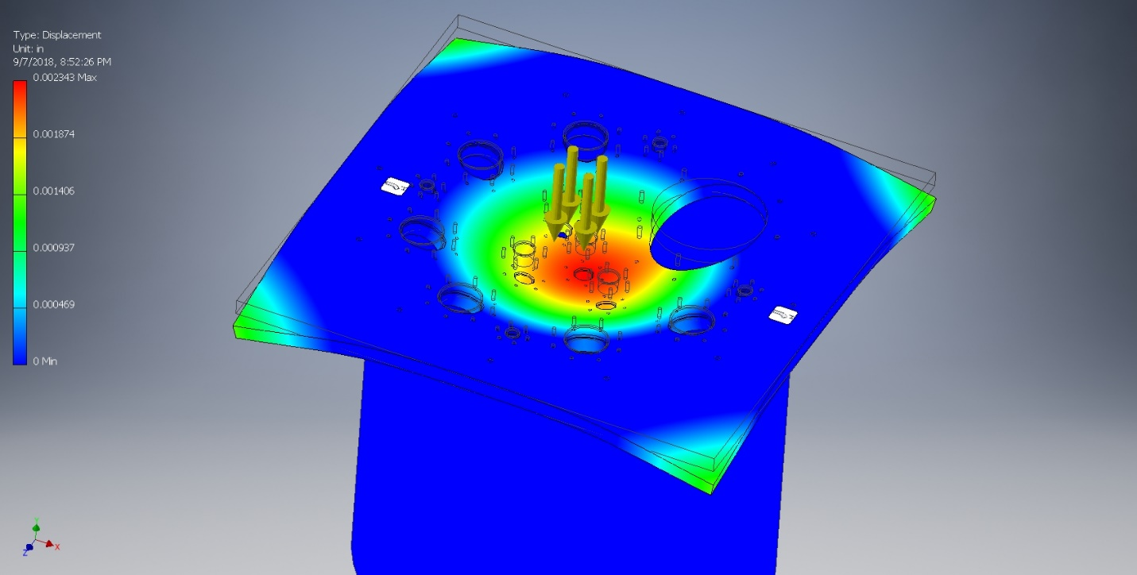

A further test with gravity found no difference. Also initial investigations into the natural harmonics of the steel plate show that modifying the orientation of the holes does not have a significant effect on the dominant vibrational mode. You can see that the spherical harmonics for a disk are predominant (as expected) with additional modes due to the corners vibrating.

# Top Plate Design

## Spira EMI shielding

Spria-shield is a product manufactured by Spira manufacturing. This product looks like a long metal spiral made of a flat continuous strip of metal. The intended use of Spira is providing EMI shielding by sandwiching the Spira between two metal surfaces. The Spira then provides conductive contact between the two metal surfaces screening EMI.

In talking with sales reps from Spira they informed us that for the Spira to effectively screen EMI it must be at 20-25% compression with 25% being the ideal, and that moving away from this ideal compression leads to a rapid drop off in EMI shielding performance.

## Vacuum Jacket Bolt Pattern

The vacuum jacket bolt pattern has been measured properly. Test holes drilled in acrylic with the desired spacing. Test hole was fit on every pair of bolts. The center to center dimension which works is 530.5mm. Using a 24” Vernier the bolt to bolt spacing measured by screwing in a pair of M8 bolts in opposite holes and measuring the greatest distance between the heads of each bolt. The distances measured for two sets of holes was 21.381” and 21.385”. The bolt head a nominally 1/2” diameter head. To within small error the center to center spacing is then 21.381-0.5”. Which makes the measured spacing 530.377mm and 530.479mm. A test hole was made with the dimension 530mm and this did not fit nicely (might have been within the clearance hole tolerance). Using 530.5mm had the test piece fit nicely in every bolt pair.

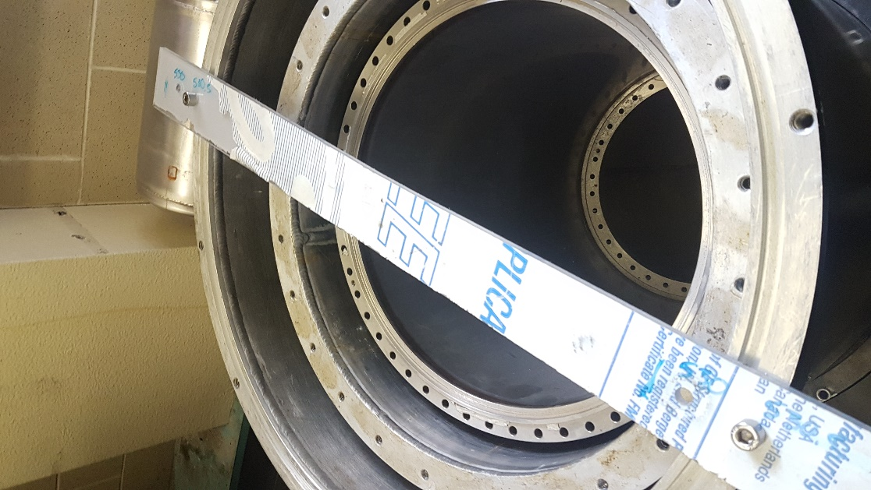

# Radiation Shield

The purpose of this is to reduce the radiated heat leak into the coldest part of the cryostat. (Pg.10 “Experimental techniques in condensed matter”). The first design question addressed was whether to use some pre-existing shields or to manufacture our own. We have decided to repurpose some shields which were laying around, whether this is the best option has not been fulled explored. Of primary concern is the weight of the shields, with secondary concern that they consume too much of the space in the cryostat.

Of the available pre-existing shields here are dimensions and weights:

|  |  |  |  |  |  |  |
| --- | --- | --- | --- | --- | --- | --- |
| Part | ID | OD (in) | Height (in) | Thickness  (Thou) | Weight (lbs) | Material |
| 55K top | 14.5 | 17 | 18.6875 | 186 | 22 | Al |
| 55K bottom | 14.5 | 17 | 25.5 | 186 | 30 | Al |
| 2.8K shield | 11.375 | 12.75 | 32 | ~<140 | 20 | Al |
| Vacuum shield short | ~19 | ~21.5 | ~19? |  | 32 | Al |
| Vacuum shield long | ~19 | ~21.5 | ~40? |  | 70 | Al |

Also note that the radiation shields available are not the right height for this purpose. As a result they will have to be cut to length, which might be as much work as making custom shields.

For comparison the weights of the radiation shields in the D-wave Cryostat

|  |  |  |
| --- | --- | --- |
| Part | Wall Thickness (thou) | Weight (lbs) |
| 55K Radiation shield (top) |  | 6 |
| 55K Radiation shield (bottom) |  | 15 |
| 2.8K Radiation shield | 66 | 13 |

*note that the thicknesses were estimated using a micrometer and a drill bit so the accuracy of the measurement isn’t excellent.

## Cooling Time Calculation

Using basic unit analysis to calculate how long it will take to cool a 22lb aluminum radiation shield:

$$coolingrate=40\left[W\right]=40\left[\frac{J}{s}\right]\left(@45K\right)Alheatcapacity=921\left[\frac{J}{kgK}\right]heatcapacity=921*\left(22lbs\right)=921*9.97kg=9200\left[\frac{J}{K}\right]cooltime=\frac{9200}{40}*\left(300-45\right)K=59000\left[s\right]=16\left[hr\right]$$

This calculation is a good starting point but ignores the fact that heat capacity is a function of temperature which trends towards zero at low temperatures, meanwhile cooling rate is also temperature dependent, increasing with temperature. Thus this is a gross overestimate of the cooling time.

## PT415 cooling power

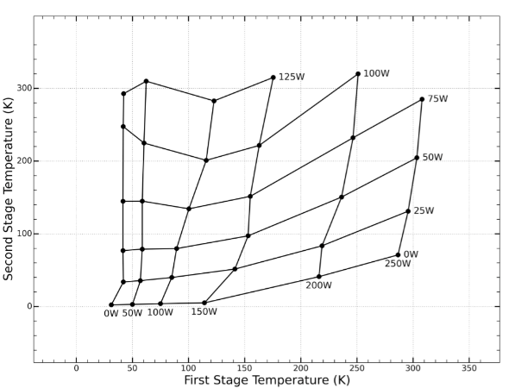

Looking at “Second stage cooling from a Cryomech PT415 cooler at second stage temperatures up to 300 K with cooling on the first-stage from 0 to 250 W” by green if the second stage is sufficiently cold then the first stage cooling power can be estimated as:

$$CoolingPower=15.65\sqrt{T-31.34}$$

## Heat Capacity

The heat capacity of a metal changes as a function of temperature. This can be a very complicate subject, luckily for temperatures above 10K the heat capacity in a metal is dominated by the phonon contribution which provides a simple model for the heat capacity.

$$C_{ph}=9R{\left(\frac{T}{Θ_{D}}\right)}^{3}\int_{0}^{X_{D}}{\frac{x^{4}e^{x}}{{\left(e^{x}-1\right)}^{2}}dx}$$

Where R is the gas constant, T is the temperature $Θ_{D}$ is the Debye temperature for the material, and $X_{D}$ is equal to ${Θ_{D}}/T$. This equation can be numerically integrated fairly easily.

Comparing the numerical results to experimental results from “PROPERTIES OF SELECTED MATERIALS AT CRYOGENIC TEMPERATURES” by Peter E. Bradley and Ray Radebaugh shows a good agreement, especially for copper. For some reason there is a small offset in the aluminum data, it may be an error in the calculation not the theory.

## Total Cool Time

The next step is to combine the cooling power and heat capacity at temperature to determine the total cool time per kilogram. This will underestimate the cool time by some amount, partially due to the underestimation of cooling time in the theory seen in the heat capacity plot, and partially due to the fact that head conduction is also a function of temperature. The conducted heat is less at lower temperatures. With this as the low bound we will have bounded the cooling time between the gross overestimate above, and the (hopefully) mild underestimate here.

The cool time is given by:

$$t=\int_{50}^{300}{16\sqrt{T-31}}\left(9{R\left(\frac{T}{Θ_{D}}\right)}^{3}\right)\int_{0}^{\frac{Θ_{D}}{T}}{\frac{x^{4}e^{x}}{{\left(e^{x}-1\right)}^{2}}dx}dTR\frac{144}{{\left(Θ_{D}\right)}^{3}}\int_{50}^{300}{T^{3}\sqrt{T-31}}\int_{0}^{\frac{Θ_{D}}{T}}{\frac{x^{4}e^{x}}{{\left(e^{x}-1\right)}^{2}}dx}dT$$

Doing this math gives a lower bound on the cool time as:

|  |  |  |
| --- | --- | --- |
| Material | Time (min/Kg) | Time (min/L) |
| Aluminum | 15.1 | 41.0 |
| Copper | 7.52 | 67.4 |

Which puts the cool time of 50lbs of 55K shield at around 5hrs. Conversely if the 55K shield can be brought down to a space age weight of 15lbs the cool time would be 100min. The results are summarized in the plot below. The way to read the figure is pick a desired end temperature for the 55K stage, then the plot tells you how long it takes to reach that temperature.

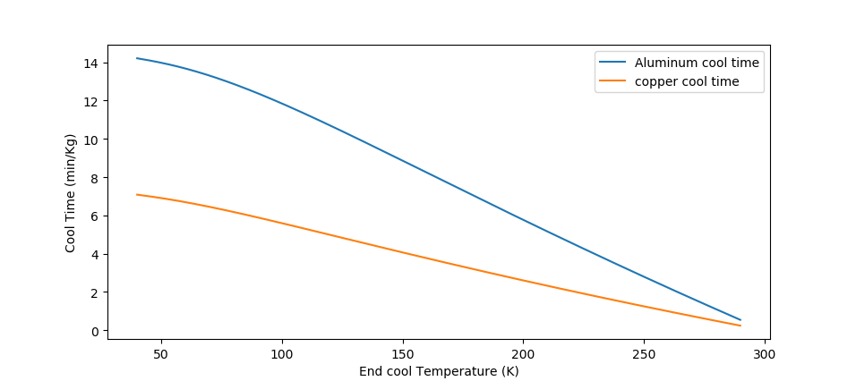

## Thermal Conduction

The next correction needed is the decrease in cooling rate due to a finite thermal conduction. That is to say it takes some amount of time for the heat stored at the bottom of the design to reach the PT cooler. This could potentially be a lot of time. Thermal conduction is again a parameter which is affected by temperature, however in contrast to heat capacity, the thermal conduction gets worse as the temperature decreases.

Another factor that needs to be investigated is transferring the heat from the various stages to the PT cooler. Existing cryostats have a fexible copper braid to transfer the heat, this allows the vibrations from the PT cooler to be decoupled from the experimental stages. Also differential thermal expansion is compensated for by using the braided cable.

The existing cable from the manufacturer looks like the picture bellow and is very expensive to purchase from the manufacturer. A local welding company, Grand Valley Weld, has confirm that they can weld copper and this might be a route for achieving the fit and finish seen in the photos. However a question arises in whether it’s necessary to weld the copper or if it’s acceptable to just crimp the cables.

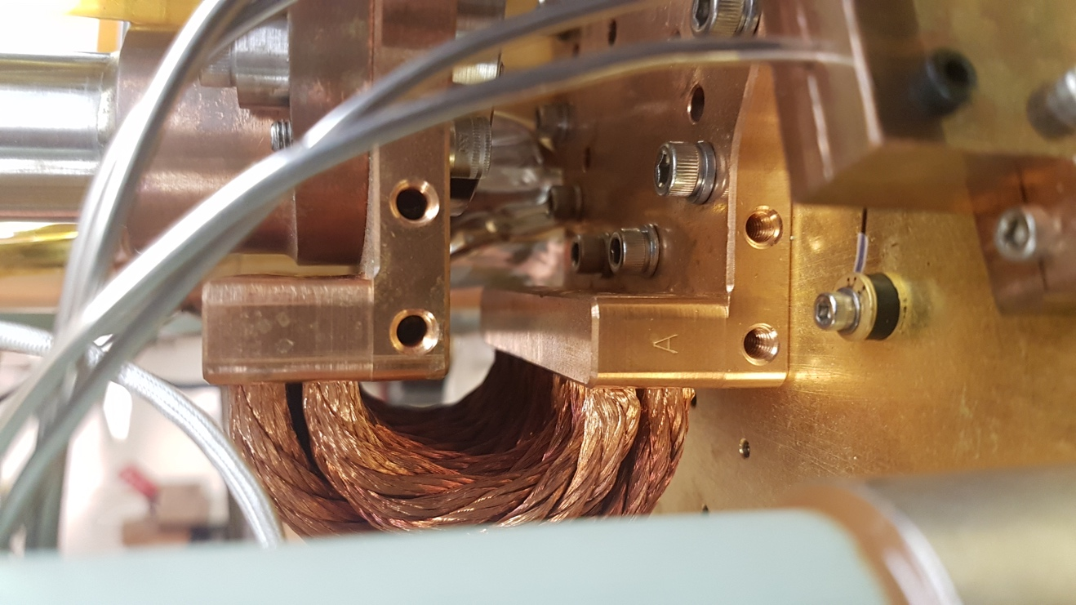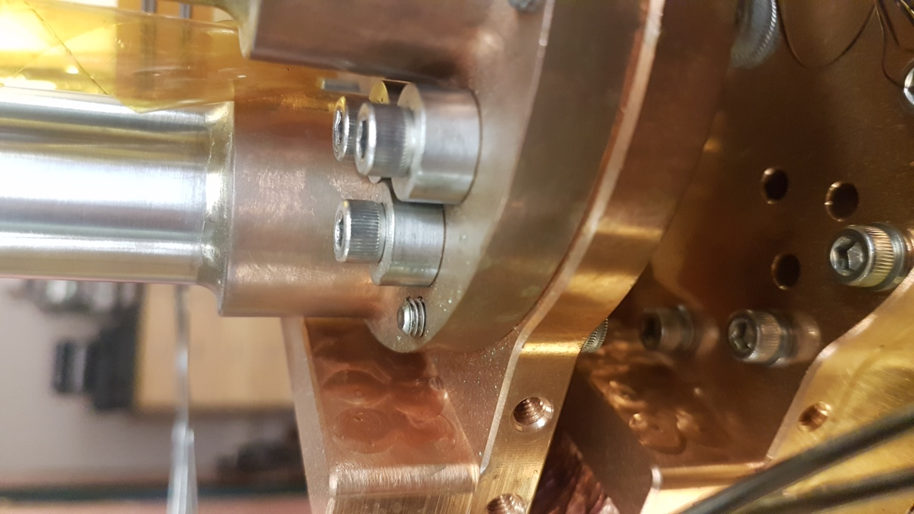

Since the thermal conductivity is proportional to the electrical conductivity the simplest way to go about figuring out whether crimping is good enough is to measure the electrical resistance of this joint. Since we’re talking about the resistance of a copper connection normally thought of as a perfect conductor we’ll need to use the 4-wire method.

### 4-Wire Method

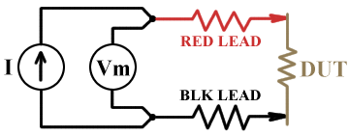A conventional 2-wire resistance measurement uses a single pair of leads through which the multimeter drives a known current and measures the resulting voltage across the element of interest. As shown in the picture to the left, a multimeter will internally have a current source and a volt meter. The current will go through the lead resistance, and the contact resistance of the probes and the voltage will measure the voltage drop across all of this.

$$V=IRI\left(R_{lead}+R_{DUT}+R_{lead}\right)2IR_{lead}+IR_{DUT}\lim_{R_{lead}≪R_{DUT}}{→IR_{DUT}}$$

The problem arises when the lead and contact resistance is not much smaller than the device under test (DUT) resistance. In this case the reading is no longer accurate. This is where the 4-wire measurement comes into play.

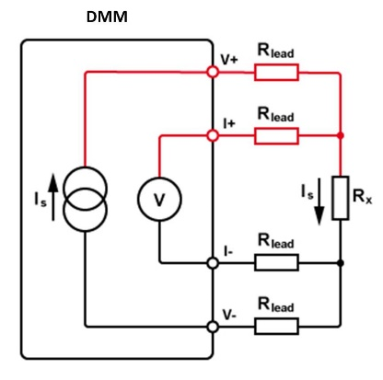In the 4-wire the current source is separated from the voltage reading. The reason this eliminates contact resistance issues can be illuminated applying Kirchhoff’s rules for voltage and current. Namely that the voltage drop around a loop is zero, and that the sum of currents at each junction is zero:

$$\sum_{k}{V_{k}=0},\sum_{k}{I_{k}=0}$$

Looking at the junction going into the positive lead of the multimeter (where R_load, Rx, and Is meet). The current law looks like:

$$\sum_{k}{I_{k}}=I_{s}-I_{m}-I_{x}=0I_{s}=\frac{V_{m}}{R_{m}}+\frac{V_{x}}{R_{x}}$$

Note that the resistance of the multimeter is typically 1Mohm. With the actual resistance including contact resistance and lead resistance given by:

$$R_{m}=R_{contact}+R_{lead}+R_{multimeter}+R_{lead}+R_{contact}$$

But the contact and lead resistances are typically on the order of 1ohm, while the internal resistance is orders of magnitude larger. Thus:

$$R_{m}≅R_{multimeter}=10MΩ$$

Thus we have effectively removed the influence of the contact resistance in the voltage measurement. Now to move forward with the current loop we need to know the voltages, using kirchoff’s voltage law we get:

$$\sum_{k}{V_{k}}=V_{m}-V_{x}=0V_{m}=V_{x}=V$$

Thus:

$$I_{s}=\frac{V}{R_{m}}+\frac{V}{R_{x}}≅\frac{V}{R_{x}}$$

Which states that we can find the resistance value of interest knowing the voltage across the resistor and the current from the current source. Also note that the lead resistance of the current source doesn’t matter because the current law says that the current in is the current out of a junction, and all we care about is the current at the resistor of interest.

Vacuum Testing

All the outer vacuum components were assembled and finally leak testing has started.

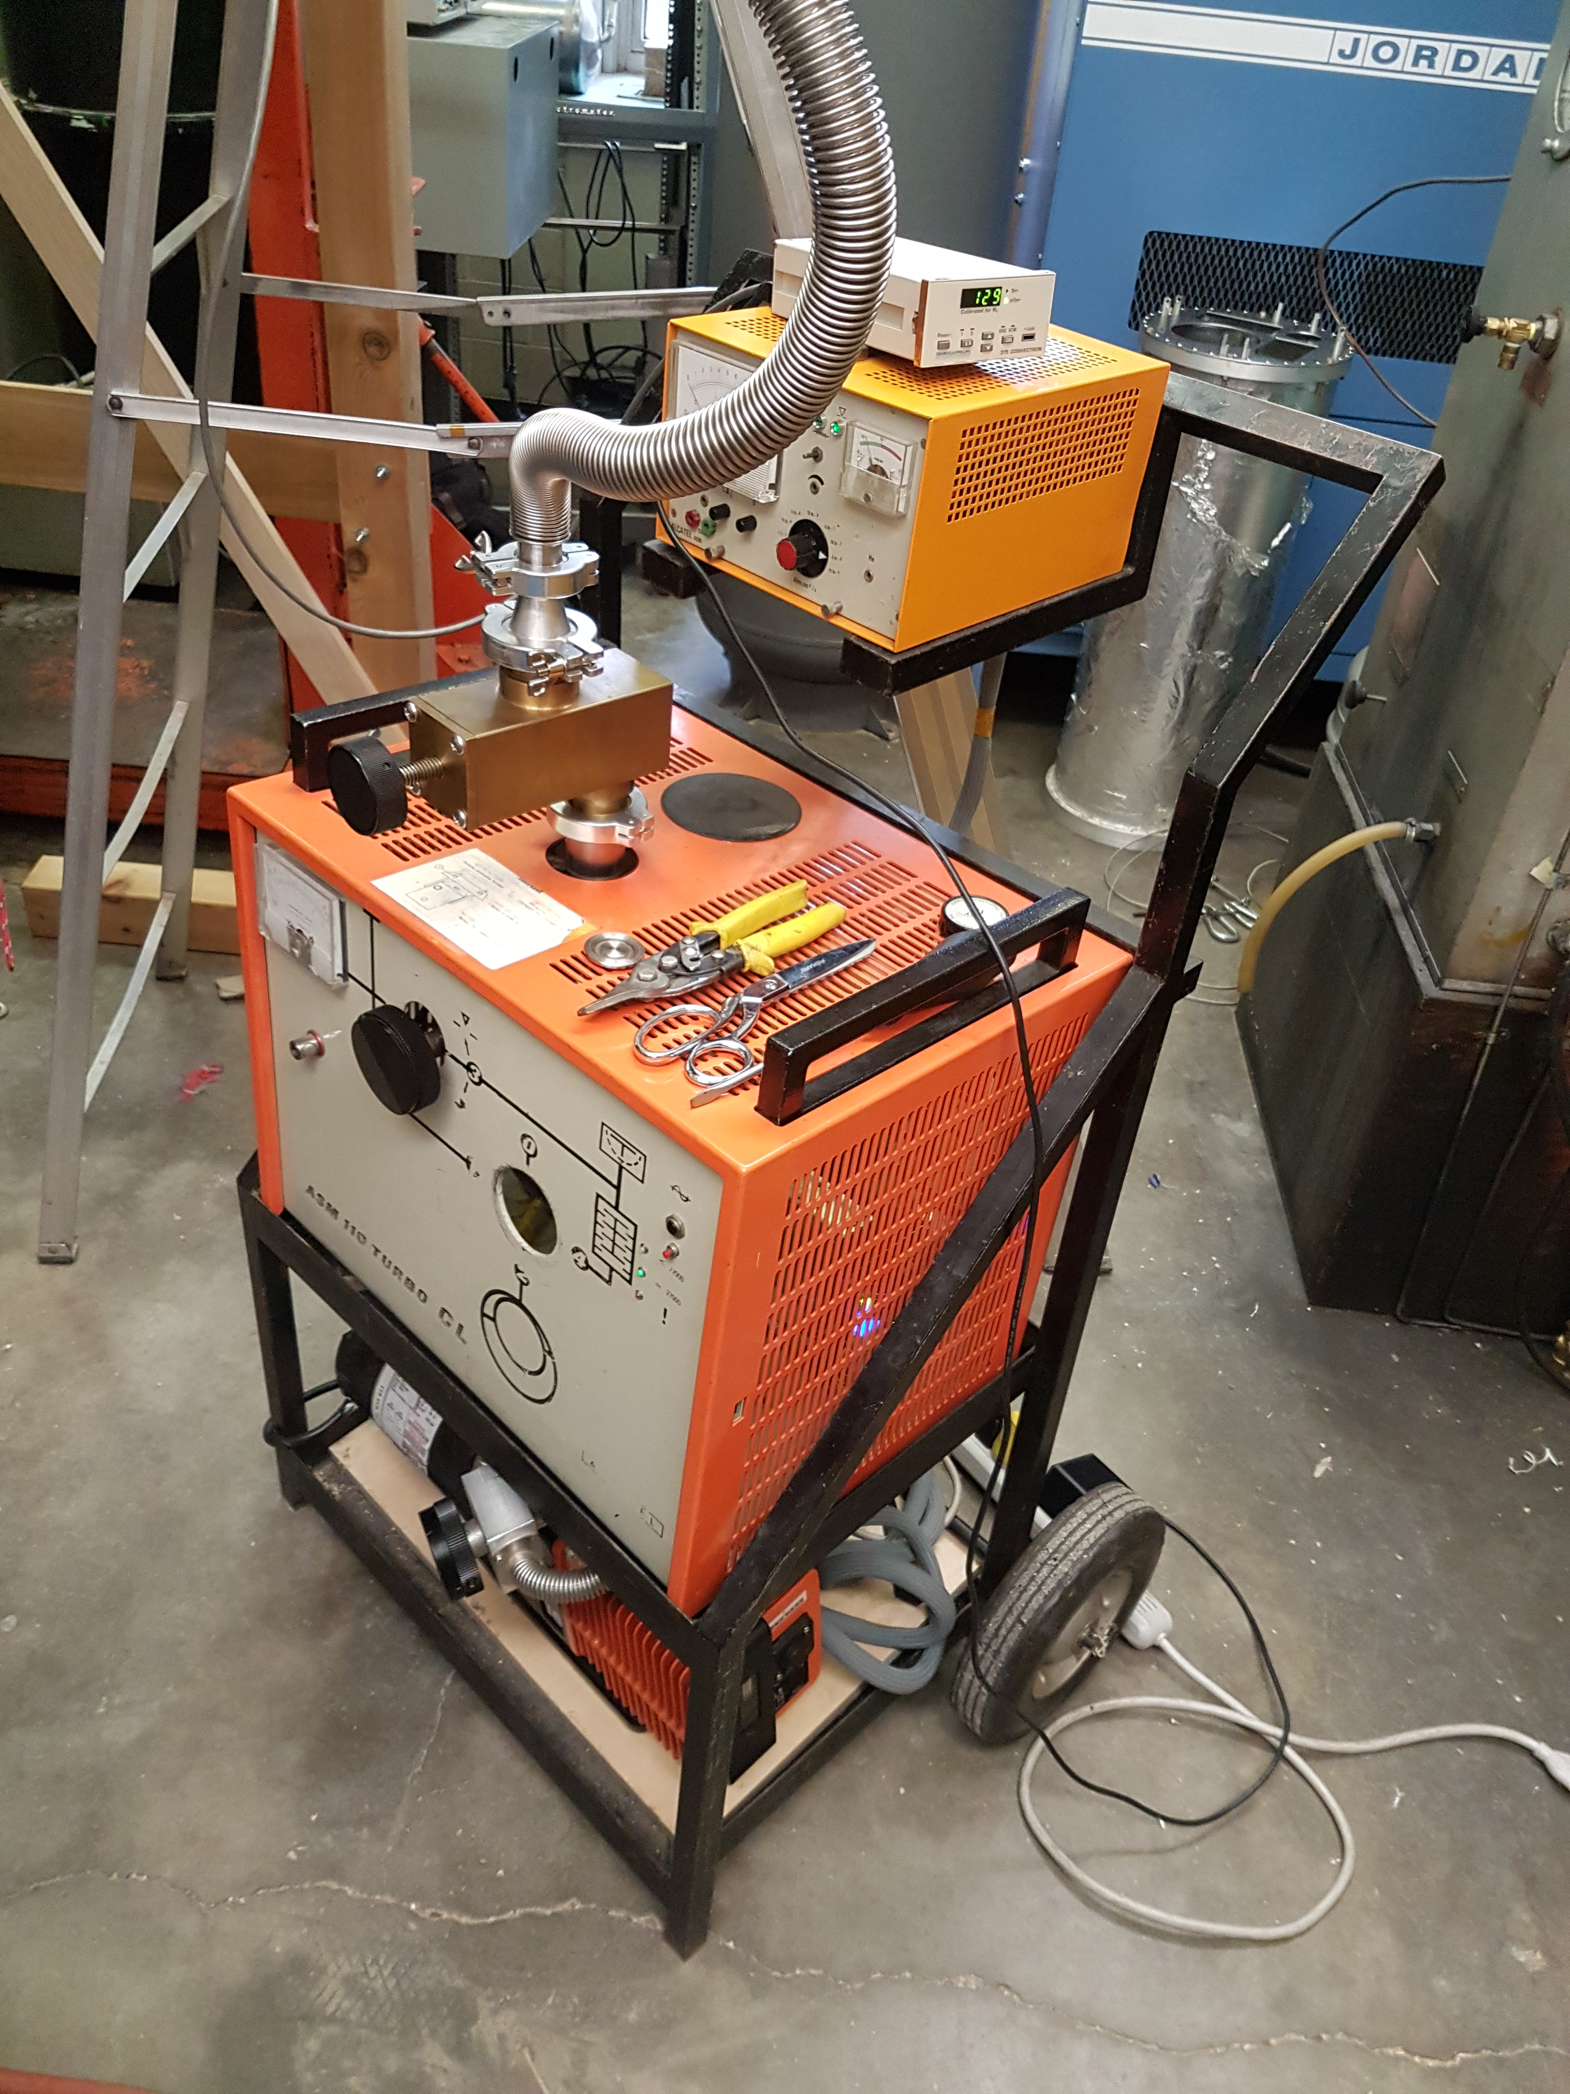

The leak check consists of two pumps, two valves, and one mass spec tuned for helium. The basic idea for the leak checker is to pump the device under test down to a sutably high vacuum, then exhaust helium gas at all of the potential leak locations on the device under test (DUT). Helium is almost the smallest gas molecule, and so if it can’t get into the DUT then it’s basically leak tight. The presence of He in the DUT is detected using a mass spectrometer which separates charged particles by their charge to mass ratio. When the device is tuned for He ions, the mass spec signal is proportioanl to the He finding it’s way through any leaks. This principle is used in almost every leak checker, however individual models will vary.

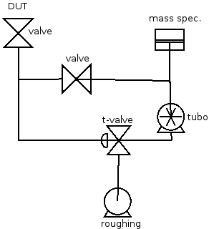Our model specifically has a roughing pump and a turbo-molecular pump. Additionally it has two (three?) valves to allow control of which pump is pumping on what.

The procedure would be to connect the DUT and pump on it with the roughing pump until ~500mTorr range. The T-valve is then flipped so that it pumps on the back of the turbo pump and the DUT simultaneously. The turbo pump will spin up when the back vacuum is sufficient.

With turbo in the green and the DUT at ~200mTorr the t-valve is switched so that the roughing pump only pumps on the back of the turbo. The horizontal valve can then be slowly throttled. Exposing the turbo and mass spec to the DUT too fast will cause a potentially damaging pressure differential. The fillament can be turned on and used as a guide to see the throttling of the horizontal valve.

When the h-valve is fully open you must wait for the vacuum to get ~50mTorr for the mass spec to work properly. If the DUT is dirty/rarely used it may need to pump on it overnight to degass all the surface He?

To calibrate the mass spec put a calibrated He source in as the DUT. Follow the regular pump down procedure. Once the vacuum is good enough to test the He in the mass spec. set the scale to the correct division, calculate the He source concentration taking into account the decay over time. First adjust the He turn pot which adjusts the mass spec. Maximize the signal with He. Bring that maximum to the calibrated value with the zero knob.

## Heat Load of Still Pipe

$$Q=\frac{A}{l}\int_{T1}^{T2}{KdT }$$

Heat conduction of still pipe from 300K to 55K for a 50mm Still pipe (KF50) with a wall thickness of 30thou (0.75mm). The pipe length is say 6” (150mm).

The heat conductivy varies with temperature, so for jumps from 300 to 55, the maths can be non-trivial. So we look up the number in a table:

|  |  |  |
| --- | --- | --- |
| Material | 300 to 0K (W/mm) | 77 to 0K (W/mm) |
| Stainless steel | 3 | 0.32 |

|  |  |
| --- | --- |
| Diameter (mm) | Heat Load (W) |
| 50 | 2 |
| 25 | 1 |
| 13 | 0.5 |

Again the same calculation for a still pipe from 77 to 0K:

|  |  |
| --- | --- |
| Diameter (mm) | Heat Load (mW) |
| 50 | 250 |
| 25 | 120 |
| 13 | 62 |

The key takeaway is that the heat load is linear in surface area, and the surface area for thin enough walled tubing goes as the circumference. So reducing the diameter produces a linear change in the heat load. Since pumping throughput goes to the power of 4 or 3 it really doesn’t make sense to reduce diameter in order to reduce heat load if avoidable.

## Appendix: weights and dimensions of things

|  |  |  |  |  |  |  |
| --- | --- | --- | --- | --- | --- | --- |
| Part | ID | OD (in) | Height (in) | Thickness  (Thou) | Weight (lbs) | Material |
| 55K top | 14.5 | 17 | 18.6875 | 186 | 22 | Al |
| 55K bottom | 14.5 | 17 | 25.5 | 186 | 30 | Al |
| 2.8K shield  (long foil covered shield) | 11.375 | 12.75 | 32 | ~<140 | 20 | Al |
| Vacuum shield short | ~19 | ~21.5 | ~19? |  | 32 | Al |
| Vacuum shield long | ~19 | ~21.5 | ~40? |  | 70 | Al |
| Copper scrap | 13 |  | 1/8 |  | 2.6 | Cu |
| Copper scrap 2 | 13 |  | 1/8 |  | 3.2 | Cu |
| Copper weight |  |  |  |  | 35 | Cu |
| Lead weight |  |  |  |  | 25 | Pb |
| Lead weight 2 |  |  |  |  | 30 | Pb |

Projected weights using CAD software

|  |  |  |
| --- | --- | --- |
| Part | Weight (lbs) | Material |
| 55K shield | 0.75 | Aluminum |
| Self rolled 55K shield |  |  |